Studio Handbook

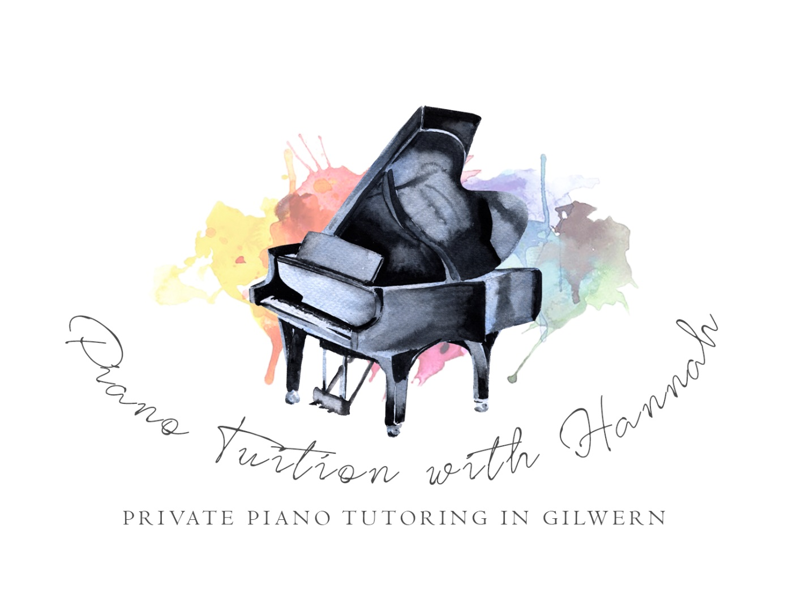

Last Updated: September 2021

A Welcome from Hannah

Hello! It’s great to have you and your child as part of our studio family, and I hope that your child really enjoys their time with us exploring the world of music. Our studio currently caters for pupils aged 5+, from total beginners up to Grade 8. During your child’s time with us, they will receive weekly piano lessons, and, as they progress, there will be opportunities to broaden their knowledge by taking classes in music theory, musicianship workshops and duet/trio classes. All students are encouraged to take part in performance opportunities – these are great fun, and really help to build each child’s confidence, as well as letting them experience a whole range of performance styles and abilities from other students.

This handbook has been designed to help both you and your child in getting the most out of their piano studies. It also contains all the information you need to help lessons run smoothly.

Please could you take the time to read through all the information provided, and fill in the relevant forms. These can be signed and returned at the start of your child’s next lesson, or signed and scanned at home and emailed to myself.

Thank you for choosing myself as your child’s piano tutor. I’m looking forward to helping them develop their musical ear, and hope that they will be keen to show you their new skills after each weekly lesson!

Studio Contact Details

**Address: Email Phone**

Old Library [hannah@pianogilwern.com](mailto:hannah@pianogilwern.com) 07863331349

Main Road

Gilwern

NP7 0DE

**Finding Us:**

Our studio is based at the Old Library in Gilwern, currently known as ‘Gilwern Village Hall’. The building is just off the main street in Gilwern. As you turn off this street as if heading towards Crickhowell, the hall is on the left, opposite the Beaufort Inn. The building itself has a small car park out the front. This can get busy, and alternative parking can be found along the main street as well as in the free public car park just past the Londis shop.

Lessons

**Lessons run weekly during school term times**. At the end of a term / half term, we run through to the end of that week (i.e. if the schools finish for the holidays on a Friday, we will teach until the Sunday at the end of that week). Likewise, we start each term on a Monday. In addition, students are encouraged to arrange two or three lessons during the long Summer break, or book onto one of our Summer Courses.

Your child will have a weekly time slot for their lesson. Your monthly invoice will show all dates and times for lessons during the upcoming month. If they are unable to attend a lesson, you can cancel their lesson and a make-up credit can be issued, providing at least **24 hours notice** has been given. The credit can be used for the remainder of that academic term – **it is the parent/student’s responsibility to book this make-up lesson**, and the tutor’s responsibility to keep parents/students aware of any available slots. Each student is **limited to two make-up credits per academic term** (i.e. Autumn Term, Spring Term, Summer Term). Any further cancellations during the term unfortunately cannot be made-up. **We are unable to carry make-up credits over to new academic terms**. Should a student/parent prefer, we can also offer video feedback for the missed lesson, whereby the student sends a practise video to their tutor, and receives feedback to help them progress during the week. We ask that all cancellations are made with as much notice as possible – this is really helpful to other students who are looking for available slots to have make-up or extra lessons. No refunds can be given for lessons missed/cancelled by the parent/student.

Lesson Durations and Charges

The following weekly lesson durations are recommended, based on the level which a student is working at:

* Beginner up to Grade 1 = 30 minutes individual lesson or 1 hour Piano Lab
* Grades 2 - 4 = 45 minutes individual lesson or 1-2 hours Piano Lab
* Grades 5+ = 1 hour individual lesson or 2 hours Piano Lab

Lessons are charged per calendar month in advance, at the following rates:

Individual Lessons:

30 minutes = £16.50

45 minutes = £24.75

60 minutes = £33

Piano Lab:

60 minutes = £16.50

Parent and Student Responsibilities

1. Ensuring **invoices are paid punctually**
2. **Arriving promptly** to lessons
3. Making sure that the student arrives with **clean hands, nails cut short** (no fake nails please!), and wearing **footwear suitable** for using the pedals on the piano (please no muddy boots). Please use the toilet prior to arriving
4. Children who are unwell must remain at home please – online lessons and practise feedback videos are available as alternatives to coming to the studio
5. Arriving with the necessary **learning materials** (purchasing books as needed)
6. **Parents/guardians are to remain contactable during lessons**
7. Being **respectful** of others when at the studio. We ask that noise levels are kept to a minimum to allow lessons to continue without interruption
8. **No food, drink or gum** in the studio, with the exception of water bottles
9. **Lesson notes with practise guidance will be emailed** at the end of each lesson. It is the parent/guardian’s responsibility to ensure that the pointers are being followed during daily practice. For younger children this will mean that parents need to be present during each daily practice session
10. **A suitable instrument at home** is necessary. A keyboard is fine for beginners, but after 12 months of lessons an acoustic piano or full size digital with weighted keys is needed
11. **Home practise is expected** in order for your child to get the most out of their piano lessons. As a rough guide, the following frequencies/durations of practise are suitable, based on age/ability:

- Very young beginners: 5-10 mins, minimum 3x per week

- Beginners – Prep Test Level: 10-15 minutes, minimum 4x per week

- Grades 1-2: 15-20 minutes, minimum 4x per week

- Grades 3-4: 20-30 minutes, minimum 5x per week

- Grades 5+: 45 minutes, minimum 5x per week

Teacher and Studio Responsibilities

1. Ensuring that the **studio environment** is suitable for learning, including maintaining the studio piano, keeping the area clean and tidy, and providing the necessary learning materials during each lesson
2. **Arriving promptly** and well prepared for lessons, being courteous, professional and friendly, and making sure that each lesson is planned to enable the student to work to the best of their ability
3. Maintaining open and effective communication with parents/guardians
4. For students working towards an exam: Providing **clear guidance** to both parents and students about the format of the exam, and the work needed to achieve the desired award prior to the entry being submitted. Keeping parents informed as to the progress being made, and areas which need additional input. Providing the option of additional lessons in the weeks leading up to the exam (charged at the normal lesson rate)
5. Following **GDPR** guidelines when handling students’ information
6. Ensuring that all matters surrounding **Health and Safety, Safeguarding, Child Protection and Insurance** are kept up-to-date and in line with the necessary rules and regulations
7. Providing regular **performance opportunities** for each student
8. **Encouraging each student** to work towards their own unique goals, and celebrating their successes. I want every child to feel confident in their musical abilities and to enjoy both their lessons and music in general

Exams

Exams are offered to pupils with The Associated Board of the Royal Schools of Music. Students often begin with the Preparatory Exam (a gentle introduction to music exams), and then progress onto graded exams. Exams in Music Theory can also be taken.

Exams take place towards the end of each of the three academic terms. The exam centre is normally in Newport, and parents accompany their child to the exam. Often, these exams take place during school hours – we have always found schools to be very accommodating of the absence needed, as they see the educational value in their pupils taking music exams.

The ABRSM also have an online exam format, which might be more suitable for students in certain circumstances.

Before entering a student for a graded exam, we will speak to both the student and their parent/guardian, to ensure that they are happy to work for the exam, and understand the commitment needed, both during their weekly lessons, and at home, daily, in their practise. Parents will need to be on board with helping their child to practise at home, and ensuring that they are following the lesson notes given at the end of every weekly lesson.

Piano exams can be hugely rewarding for children – I’ve seen many beam with pride when they see their certificate, and realise that all their hard work has paid off. I’ve also found that, in working towards an exam, a student’s musical and technical ability is accelerated, as they really push themselves to reach the next level.

**PRIVACY POLICY**

**In very basic terms, I totally respect your personal information and will only ask you for the information I really need from you.  I will look after it in the same way I would want mine looking after - keeping it secure!  I will only share it with others where we need their help to deliver my service to you (such as entering your child for an agreed ABRSM music exam).  Be assured that I will never share your information in any other circumstances – nor will I sell it on elsewhere!**

Here are more details: 

**Introduction**

Hannah Merrett takes your privacy very seriously.  This privacy policy has been prepared in line with the General Data Protection Regulation (GDPR), which promotes **fairness and transparency** for all individuals in respect of their personal data.  This privacy policy applies to all data I process, and by using Hannah Merrett as your music tutor you consent to our collection and use of such data.  I am registered with the **Information Commissioners Office**.

**1. The Data I collect**

As a data controller I collect a variety of data in order to deliver my services, and I will **manage your personal data transparently, fairly and securely**.   I may ask you to provide us with the following data:

- Full Name

- Your child(ren)'s names

- Your child(ren)’s date of birth

- Your address

- Your telephone number

- Your email address

I may also ask for your consent to **photograph and/or video your child**, for the purposes of education and also to share the work of our pupils online.

I use the above data to deliver our service to you, and to personalise the service you receive.  Images taken are, with your explicit consent, used for marketing purposes and for business development.

I collect this data on the following lawful basis, by gaining your **consent**.  
When you visit my website I also collect Cookies. These are small pieces of data that websites send to a user's computer and are stored on the user's web browser. They are designed to enable the website to remember information, such as what a user might have put in a shopping cart for example. This helps me deliver my service to you, and aids with my marketing.

**2. Which third parties do I share Personal Data with?**

I share personal data with the following third parties:  **Google, Outlook, Paypal, My Music Staff, KnowHow Cloud, The Associated Board of the Royal Schools of Music, Banks, Direct Debit Companies**, and other external organisations running competitions, exams, masterclasses or performance opportunities which you and your child have consented to attend.  The above companies either do not transfer data outside of the European Economic Area, or transfer data outside of the European Economic Area to United States under the protection of EU/US Privacy Shield.

There are also certain situations in which I may share access to your personal data without your explicit consent; for example, if required by law, to protect the life of an individual, or to comply with any valid legal process, government request, rule or regulation.

**3. Why do I share your Personal Data with the above?**

I share your data in order to **deliver my service to you**, to assist with my marketing, to personalise your experience and to progress your child’s musical education through exams, performances and competitions.  
   
**4. How do I keep your personal data secure?**

I keep your data secure by following internal policies of best practice, by using Secure Socket Layer (SSL) technology when information is submitted to me through my website, and by ensuring all paper copies of information are kept in a **secure, locked environment**. In the unlikely event of a criminal breach of my security I will inform the relevant regulatory body within 72 hours and, if your personal data were involved in the breach, I will also inform you.

**5. Changes to my privacy policy and control**

I may change this privacy policy from time to time.  When I do, I will let you know by changing the date on this policy, and notifying customers of any significant changes. By continuing to access or use my services after those changes become effective, you agree to be bound by the revised privacy policy.

**6. You have the following rights:**

- The right to be **informed** about the collection and use of your personal data

- The right of **access** to your personal data and any supplementary information

- The right to have any errors in your personal data rectified

- The right to have your personal data **erased**

- The right to **block or suppress** the processing of your personal data

- The right to **move**, copy or transfer your personal data from one IT environment to another

- The right to **object** to processing of your personal data in certain circumstances

- Rights related to automated decision-making (i.e. where no humans are involved) and profiling (i.e. where certain personal data is processed to evaluate an individual)

- The option to **manage** your data via email or telephone.

Whilst I do not hold personal data any longer than I need to, the duration will depend on your relationship with me, and whether it is ongoing.  I may keep some of your personal data for up to 7 years after our working contract with you has finished for Tax legislation purposes.  Some data may be archived indefinitely.

Parent/Guardian and Student Consent Form

Name of Parent/Guardian (hereby referred to as ‘parent’): ………………………………..............

Name(s) and Date(s) of Birth of child(ren) to receive tuition (hereby referred to as ‘student’):

…………………………………………………………………………………………………..

Address: ………………………………………………………………………………………...

…………………………………………………………………………………………………..

Home Telephone: ………………………………………………….

Mobile Telephone: …………………………………………………

Email: ………………………………………………………………

Name and Telephone number for Emergency Contact (different from above): …………………...

…………………………………………………………………………………………………..

Student medical conditions, allergies and additional needs (please list all, including learning needs such as dyslexia to allow for tailored tuition where needed): ………………………………………

…………………………………………………………………………………………………..

…………………………………………………………………………………………………..

I, (parent), have read all the information in the Studio Handbook, and understand my responsibilities as a parent during my child’s time with the Studio (please select): YES/ NO

I consent to Hannah Merrett and other approved Studio tutors teaching my child, and understand that the use of touch may be necessary in order to demonstrate piano technique and correct hand positioning (please select): YES/ NO

I confirm that I have read and am happy with the Studio’s Privacy Policy, and agree to Hannah Merrett and other Studio staff contacting me via the contact details above (please select): YES/NO

Parent/Guardian Signature: ……………………………………………………………………

Date: ……………………………………

Studio Tuition Contract

This contract is between ………………………………………….. (hereby referred to as ‘tutor’) and …………………………………………………………….… (hereby referred to as ‘parent’)

**The Tutor will:**

* Provide a suitable learning environment for music tuition
* Arrive promptly to all lessons, behaving in a professional and courteous manner
* Provide regular communications to the Parent(s) and student, keeping them informed of homework to be undertaken, progress during lessons, and relevant studio news and/or information

**The Parent will:**

* Ensure that the student arrives promptly, clean and well prepared for each lesson, with any necessary learning resources
* Support practise at home, through providing a suitable instrument on which the student can practise, purchasing any necessary books/resources, and communicating details of lessons notes provided by the Tutor. For younger students, parents will need to actively help and be present with their child during practise sessions

The Studio operates the following policy with regards to fees and missed/cancelled lessons:

* Lessons operate weekly during School Term Times
* Lessons are to be paid for one calendar month in advance
* One calendar month’s notice is required to terminate lessons
* There will be no refunds for lessons missed or cancelled by the Parent. Should the Tutor need to cancel a lesson, the Parent can choose whether to have this lesson refunded or made-up at a mutually convenient time
* Up to two lessons can be rearranged within each academic term, providing the Parent has given the Tutor at least 24 hours notice

Tutor’s Signature: …………………………………………………………………….

Tutor’s Name (printed): HANNAH MERRETT

Date: …………………………………

Parent’s Signature: ……………………………………………………………………

Parent’s Name (printed): ……………………………………………………………..

Date: …………………………………..

Photography and Video Consent Form

Hannah Merrett and other appointed staff at the Studio use both photography and video of students during music lessons and events (such as competitions and concerts). These are used in a variety of ways, as set out in the Studio’s Privacy Policy which can be found both on the Studio website and in the Studio Handbook. Most notably, photographs and videos of students are used as an educational tool, and for celebrating the successes of students. We are a friendly Studio, aiming to foster a sense of community amongst our students and their families, and we feel that sharing photos and videos of students is a great tool in building a positive and supportive atmosphere. Any images taken will only be used for the purposes listed in the Privacy Policy, and, in line with The Data Protection Act, will only be kept for as long as is necessary.

In order to take photographs and videos of your child, we need your explicit consent.

(To be completed by the student’s parent/legal guardian):

I consent to Hannah Merrett and other appointed Studio staff taking photographs and videos of my child during lessons and other Studio events (please select): YES / NO

I consent to these photographs and videos being used online (please select): YES / NO